Assignment- 2

Q.1 What do you mean by minimum spanning tree? Write and explain algorithm for minimal spanning tree for a given graph using Prim’s and Kruskal’s both with source node 1.

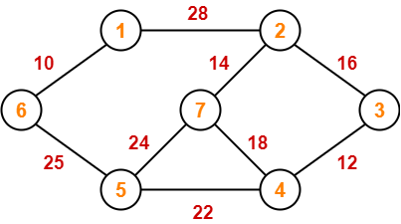

Q.2 Write an algorithm to find Single source shortest path for a given graph.

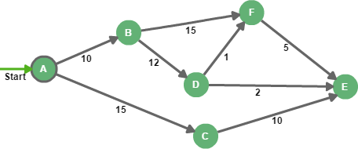

1. Show the sequence of vertices identified Dijkstra’s, source is A.
2. What will be the cost of shortest path from A to E?
3. What will be the shortest path from A to E?

Q.3 Write an algorithm to find Single source shortest path for a given graph.

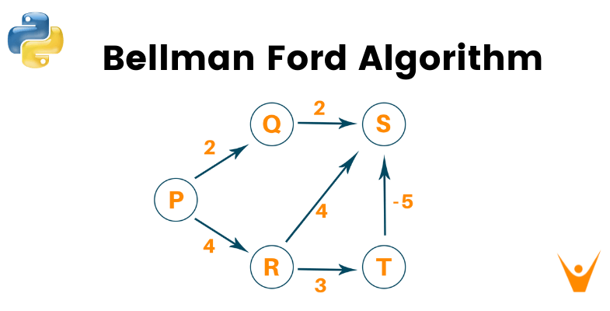

1. Show the sequence of vertices identified Bellman-Ford algorithm, source is P.
2. What will be the cost of shortest path from P to S?
3. What will be the shortest path from P to S?